Patent application technical information form

I、Name and technical field of the Invention
1、Name：Develop a name for the technical topic：
2、Technical field: this part describes the professional technical field of the invention to be applied for patent protection（ For example, a nondestructive testing system for welded structures belongs to the field of radiographic testing）

II、Technical background of the patent：

The background knowledge required to help the agent understand the invention includes:

1、 What are the problems in this field（ Fill in only the problems that can be solved by the invention)

2、 The prior art and its defects known to technicians.

In short, how do others do? What's wrong with the current practice that you need to improve?

III、Purpose of the invention (why you make this invention?)
Briefly describe what is the purpose of the invention, that is, what technical problems are to be solved by the invention?
The technical problem is corresponding to the defects of the prior art in the second part (because of what problems exist in the prior art, the invention wants to solve such problems).

IV、Beneficial effects of the invention (What are the benefits of your invention?)
This part describes the specific technical effects of the invention. The technical effects correspond to the technical problems listed in the third part, that is, what kind of technical effects can be obtained by solving the above technical problems.

It is suggested to use the dotted list to provide what effects have been achieved.

V、Key innovations and key points you want to protect (what core contents do you want to protect?)
This part clearly states the invention points you want to protect. There is no need to elaborate, just provide the key points.

For example, you want to protect key points: 1) signal transmission device 2) signal filtering conditions 3) algorithm used in step X.

VI、Complete technical scheme of the invention (how do you do specifically?)
Key points of description: compared with the prior art, the differences of the invention and how to realize the objective improvement effect through these differences.

That is, "how do you do " should be described in detail, so that others can implement the invention according to the text description. At the same time, this part also needs to describe and explain the overall technical principles, key technical principles and innovative technical principles.

VII、Alternatives (what else scheme you have?)
For the technical scheme in Part VI, is there any alternative scheme that can also complete the purposes listed above?

VIII、Attached drawings and brief description of attached drawings
This part provides (circuit diagram, structure diagram, principle block diagram, flow chart, sequence diagram, circuit diagram, local enlarged drawing, etc.) to illustrate and display the specific technical scheme content in Part VI of the disclosure.

Be Noted:

(1) Attached drawings must be provided for utility model patents.

(2) The attached drawings of the invention patent are not necessary, but they can more clearly show the technical content and support the protection requirements of the invention.

(3) Each drawing shall have necessary text description or name. The professional definition of special results (such as electron microscope, metallography, crystal phase and electrophoresis) shall be explained in words.

(4) The attached drawings shall be black-and-white line drawings or gray-scale drawings, and photos shall not be used instead of drawings; Black and white or gray photos can be provided for electron microscope, metallography, crystal phase, electrophoresis, etc. The photos of the work site can be used to help the agent understand the contents of the invention and creation, and cannot be used for the submission of patent applications.

Company Name/Creator:
United Credit code/Passport Number:
Development completion date:
Publication status: | Yes/No
Publication date:
Publication location:
Contact person (Director of the Company):
E-mail Address:
Mobile Phone No.
Contact Address:

Your signature below constitutes your express authorization for TMRegisterChina (Gomax Group and its affiliated enterprises) to act on your behalf in all matters relating to copyright application in China. Signing this section shall have the same legal effect as executing a separate power of attorney.

Sign Here:__________________________________ Date:__________________________

Required Files

- Passport for individual
- Business Certificate for company applicant
- Passport Holding Photo

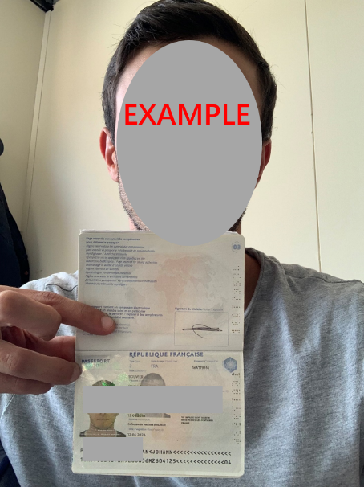

- Six-View Drawings / 3D Perspective Drawings
- Colored Sample (if applying for color protection)
- Real Product Photo or Rendered Images (optional)

